Completion Reports of Project (Civil work.)

**Completion of Sprinkle system on – 20.12.2017**

On Sat, Dec 24, 2016 at 10:22 AM, Govind Ghule <[govind.ghule@vvfltd.com](mailto:govind.ghule@vvfltd.com)> wrote:

Dear Mr. Rakesh Jain,

This is inform you that we have completed the strengthening of ware house rack. We have followed your structural audit guidelines. You are requested to have a site inspection visit on next week. Mr. Rohidas & Ravi Sonkamble will assist you during inspection.

As per our PO term you will issue us structural stability certificate once you complete the inspection.

Dear Sunil,

Pls. suggest the structural stability certificate format as you desired.

Dear Rohidas, Ravi & Gopal,

Pls. co-ordinate to Mr. Rakesh Jain for Site inspection

**Thanks & Regards,**

**Govind Ghule | Assistant General Manager | Projects-Civil Construction**

VVF [India] Limited |109, Sion East, Mumbai 400 0022, Maharashtra, India | T: +91 22 4028 2258  M- 09833778366 | W: [www.vvfltd.com](http://www.vvfltd.com/)



[cid:image001.png@01CFFF28.DE9F72C0](https://www.facebook.com/VVFGroup)  [cid:image002.jpg@01CFFF28.DE9F72C0](https://www.linkedin.com/company/vvf-ltd.?trk=top_nav_home)  [cid:image003.jpg@01CFFF28.DE9F72C0](https://www.youtube.com/user/VVFGroup)

DISCLAIMER: This email was sent from the VVF Group of companies. This email may contain information that is confidential, legally privileged or otherwise protected from disclosure. If you are not the intended recipient of this email, you are not entitled to use, disclose, distribute, copy, print, disseminate or rely on this email in any way. We have taken steps to ensure that this email is free from computer viruses and the like. It is, however, the recipient's responsibility to ensure that it is actually virus free.

**Actual Consumed budget for Civil work**

Distributed budget for Civil work = 3000000/-

Actul consumed budget for services =279835

Actul consumed budget for Materials =263206

Total Consumed for Civil work = 543041/-

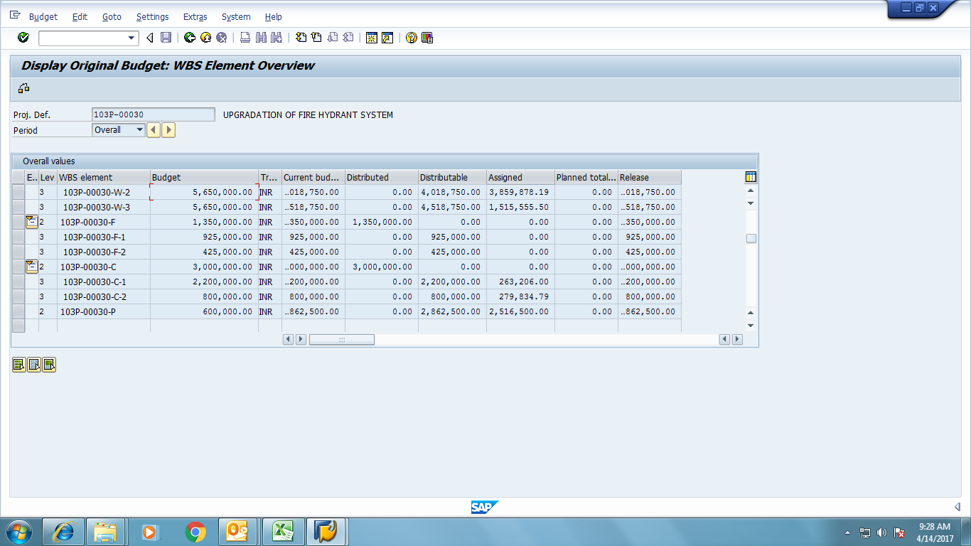

**Reference:** Stability/2017/6 **Date:** 30th January 2017

# Form No. 1A

# (Rule 3A)

**CERTIFICATE OF STABILITY**

**Name Of Factory :** M/s. VVF India Ltd.

**Village/Town/District In**

**Which Factory Is Situated :** Plot No. V-41, M.I.D.C., Taloja Industrial

Area, Taloja, Dist: Raigad,

Maharashtra - 580011.

**Full Postal Address Of Factory :** M/s. VVF India Ltd. Plot No. V-41, M.I.D.C.,

Taloja Industrial Area, Taloja, Dist: Raigad,

Maharashtra - 580011.

**Name Of Occupier Of Factory :** Mr. N. A. Kirloskar (Managing Director).

**Name Of Manufacturing Process**

**Carried On In The Factory :** Storage Of Goods

I hereby certify that, Rack Supported Warehouse No. 2 & 3, represented by plans approved by Factory Inspector vide No. XXXXXXXX dated XX/XX/XXXX & our design drawings for strengthening to support Fire Pipeline, is safe & sound enough, for its intended use.

This certificate is issued on the clear understanding that my overall design responsibility for the safety and proper performance of structural design ceases, moment any addition and / or alteration or any damage to the structural frame caused by accident or by tampering with the geometrical sections of structural members for any purpose whatsoever or due to overloading of the structure or lack of maintenance or any act that is detrimental to the structure as a whole.

Thanking You,

Yours Faithfully,

(Rakeshkumar Roopchand Jain)

A.M.I.E. No. AM-096744-3

ISSE No. M-799